

Magazine Questionnaire

Sir or Madam, this is a questionnaire to influence a new Country magazine available in Harlow College. It is aimed to 14 - 17 year olds like yourself. Your suggestions and input would be appreciated.

Thank you for your time.

- How old are you? (Please circle the appropriate choice)

14 15 16 17 17+

- What is your gender?

Male Female

- Where do you live? (Home town)

.......................................................

- Employment status?

Part Time Full Time Student Retired Unemployed

5. How often should this magazine be released?

Weekly Bi-Weekly Monthly

- Realistically, how much would you be willing to pay?

£1.00 £1.50 £2.00 £2.50

- What colour scheme would you prefer?

Pink Peach Brown Creme

Other? Please specify..................................

- Tick which cover do you prefer?

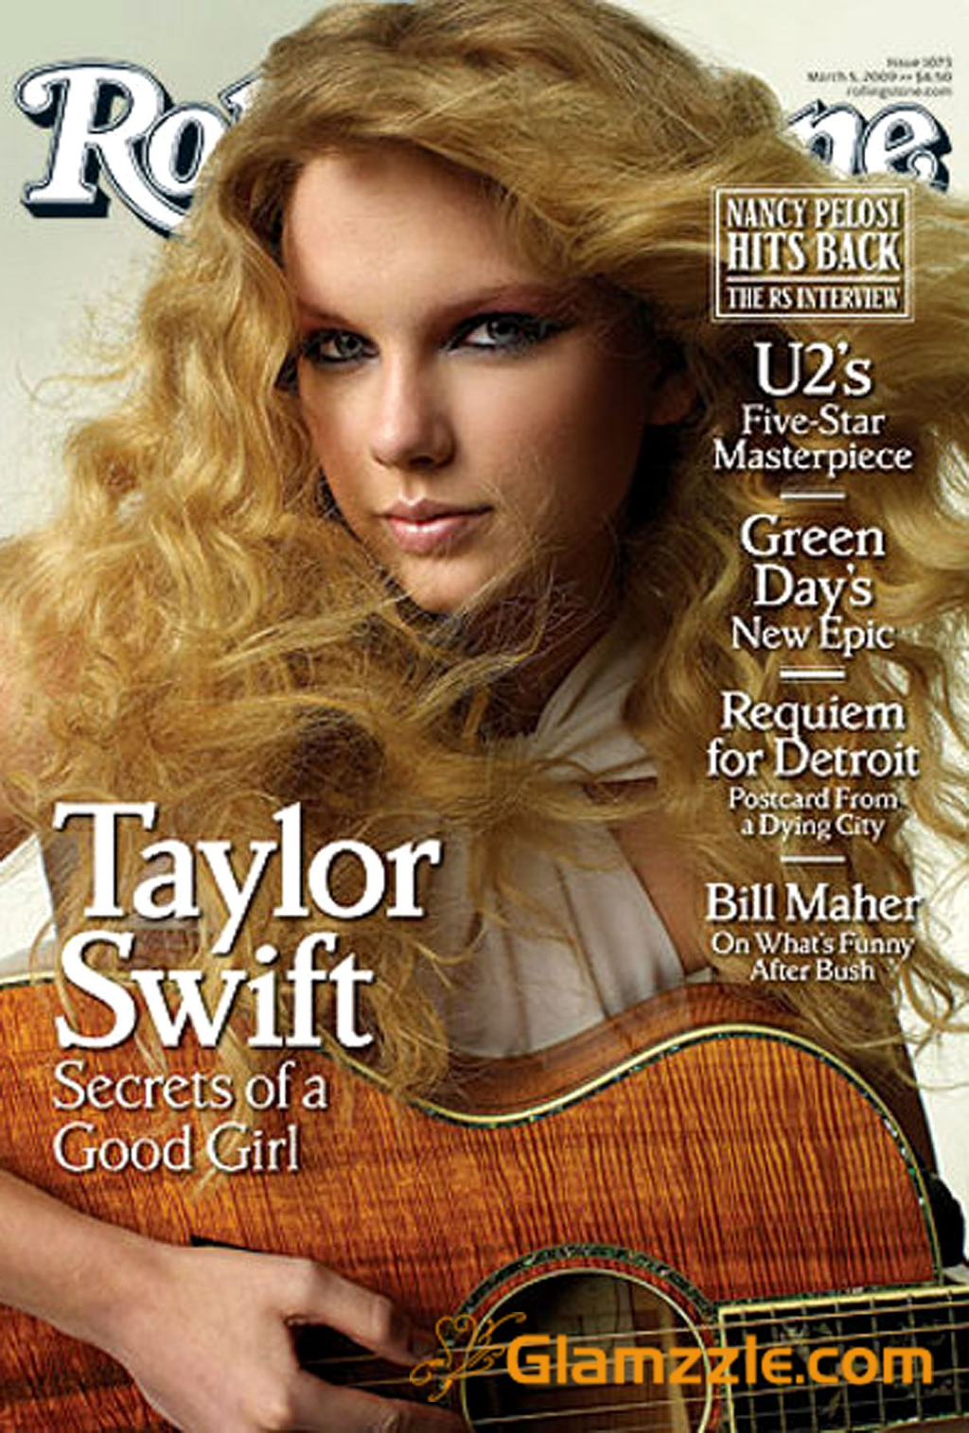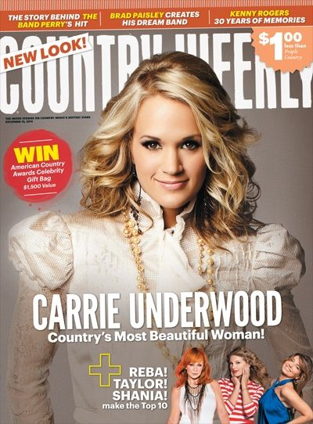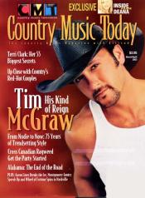

Why have you chosen this?

Model Layout Headings Colour

Other.................................................
- What title can you read best and which do you prefer?

Ayuthaya Zapfino Aachen LT Big Caslon Chalkduster CAPITALS stencil Hei

10. What free gifts would temp to you buy the magazine?

Lipgloss Poster CD Concert tickets

11. What features would you like in the magazine? (Circle two)

Album Review Biography Interview History Day in the life Awards Night
News Feature Gig Review What happened to...?

12. What language style do you prefer?

Formal Informal Simple Funny Intellectual Sarcastic Serious

13. What are your hobbies?

Music Sport Art Film Reading Other

Thank you for completing this questionnaire.

